User Manual

Model: 903W
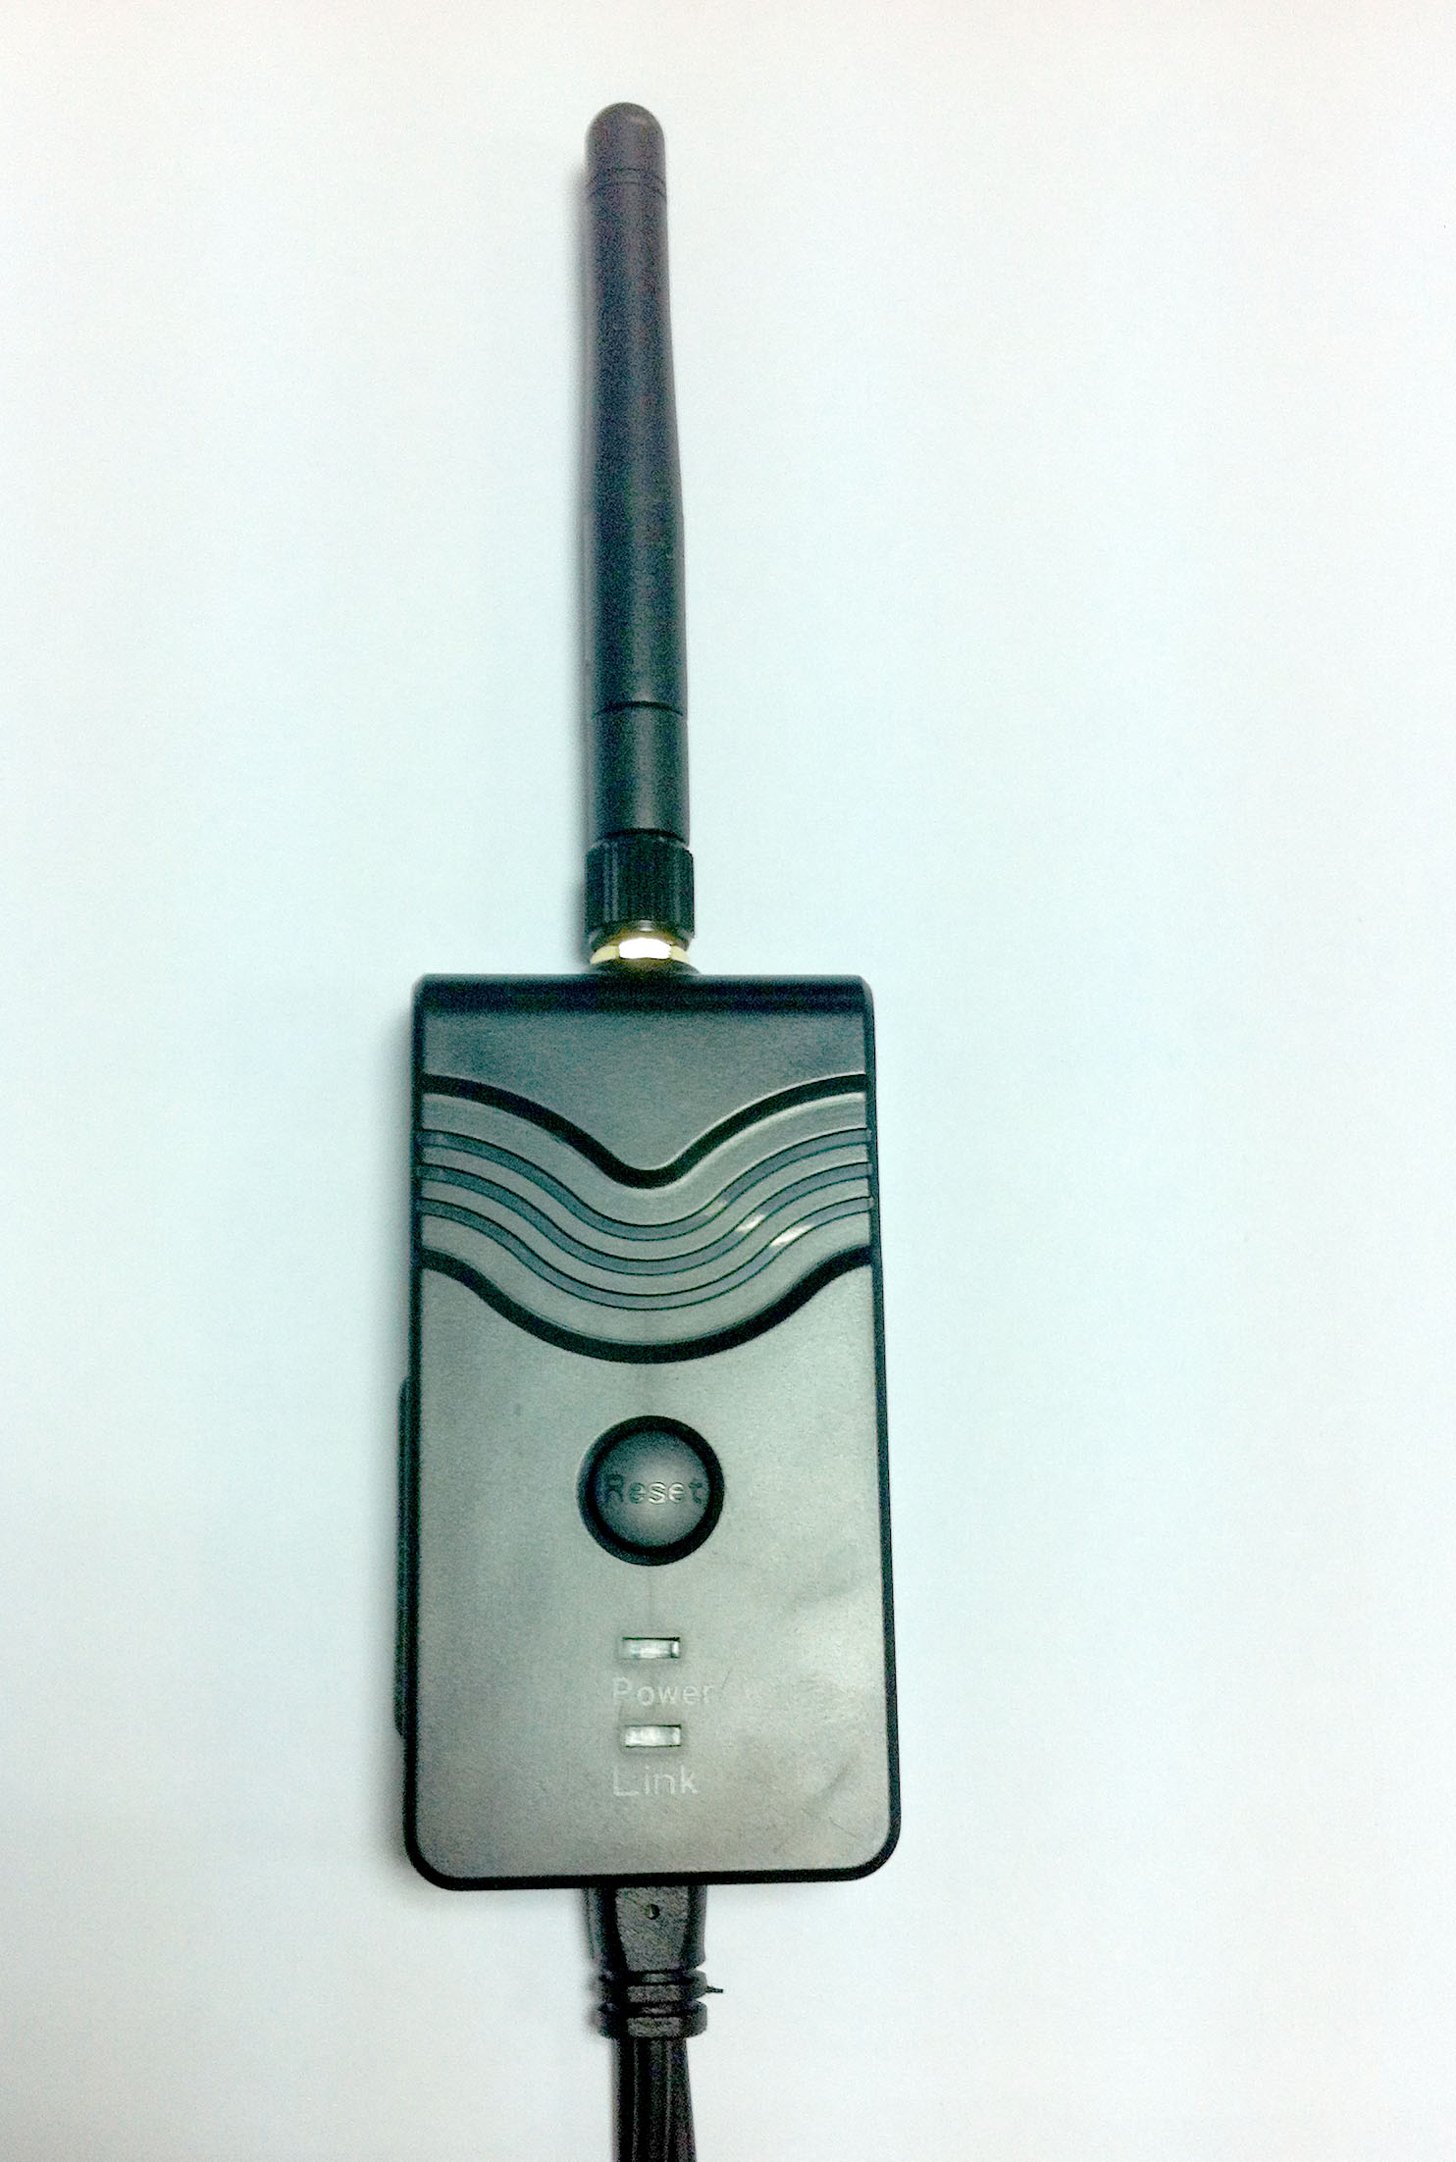

Product Features

- WiFi transmission, support iPhone, iPad, and Android phone
- Adjustable multiple angle camera viewing, with image-flip ability
- Camera & transmitter rainproof, dustproof and shockproof
- Minimum illumination less than 0.5 Lux, digital compensation for clear night vision
- Easy installation, wiring free
- 12-30VDC car power supply
- Transmission distance with no obstacle more than 150meters
- The client terminal shall support Android 2.2 or above, and iOS shall support Version 4.3 or above.

Specifications

Item |  | Specifications
Transmitter | Transmitting frequency | 2400MHz-2483.5MH
Transmitter | Modem mode | 802.11b: DSSS(CCK,DQPSK,DBPSK)  802.11g/n: OFDM(BPSK,QPSK,16QAM,64QAM)
Transmitter | Transmission distance with no obstacle | >150m
Transmitter | Frame rate | 30fps
Transmitter | Video resulutions | VGA
Transmitter | Video compression | H.264
Transmitter | Wireless protocols | IEEE 802.11b, IEEE 802.11g  IEEE 802.n(1T1RModes)
Transmitter | Power supply | DC 9-30V
Transmitter | Consumption current | 150mA (Max)
Transmitter | Encryption mode | WPA2
Transmitter | Rainproof | Yes
Transmitter | Weight | 80+-5g
 | Dimensions | 78*43*18mm
 | Operation tempreature | -10℃~+50℃
 | Operation humidity | 15%~85% RH

Operations for Android system client

♦Installation APP software:
- GOOGLE PLAY store.
- Search ”WIFIAV” software, and download.
- Install the APP software, as the following interface:
- Turn on the intelligent mobile device terminal and enter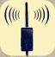

♦Connection WIFI:

- Click”wi-fi”, select your camera, and connect the wifi of the intelligent mobile device terminal to the wifi of the tool. The initial SSID of the device is “WIFIAV”, then type in the password of the device(default password: 12345678 ).
- Click the “” icon in the main interface of the intelligent mobile device terminal.

♦View the video:
Open the app, and if the connection between the wifi of the tool and the intelligent mobile device terminal is successful, the icon 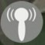will be highlighted, and the images transmitted from the wifi camera tool can be seen in the APP, as shown in the figure.

With unique image zoom in, zoom out function.

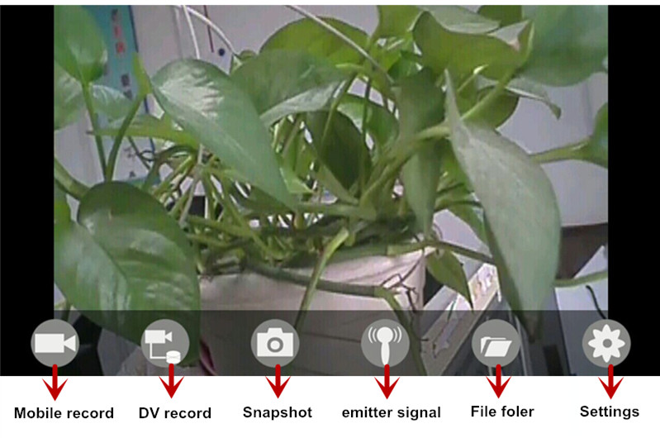

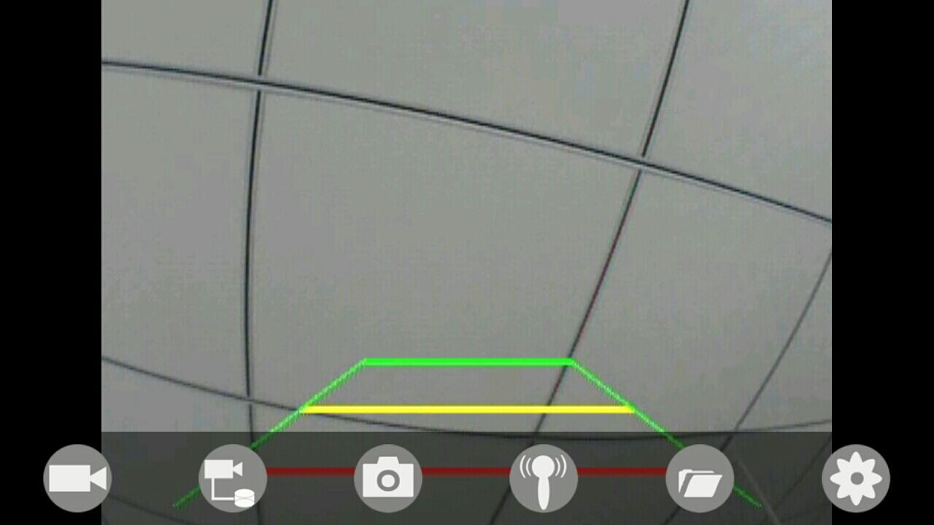

Notice：

- When the background is black or the image is still, please exit the app, and check whether the wifi connection is normal. Then click again the app icon to enter into the software interface.

♦Settings:

Press this icon to enter into the settings menu. You can change the default factory SSID and password of the wifi camera tool, and clicking will show whether the change is successful, and clicking to cancel the new SSID set.

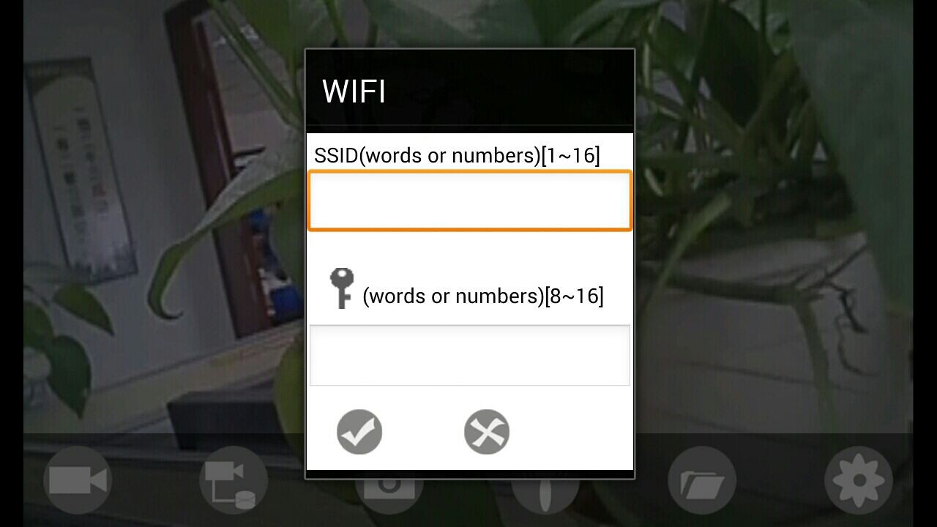

Notice：

- User could press the RESET button of the transmitter to renew the default factory SSID and password.

Operations for iOS Apple system client

♦Installation APP software:

- Turn on the intelligent mobile device terminal and enter APP store.
- Search ”WIFIAV” software, and download.
- Install the APP software, as the following interface:

♦Connection WIFI:

1. Click”wi-fi”, select your camera, and connect the wifi of the intelligent mobile device terminal to the wifi of the tool. The initial SSID of the device is “WIFIAV”, then type in the password of the device(default password: 12345678 ).

- Click the “” icon in the main interface of the intelligent mobile device terminal.

♦View the video:

With unique image zoom in, zoom out function.

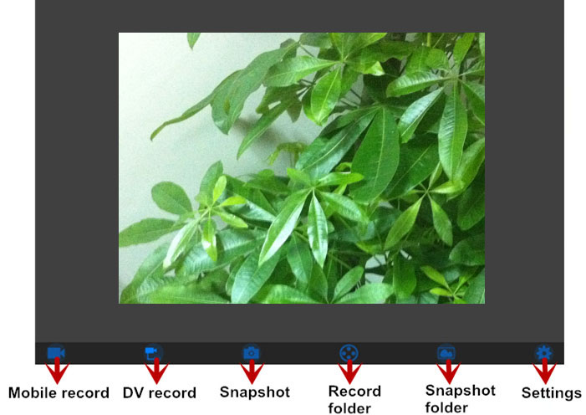

Notice：

- When the background is black or the image is still, please exit the app, and check whether the wifi connection is normal. Then click again the app icon to enter into the software interface.

♦Settings:

Press this icon to enter into the settings menu. You can change the default factory SSID and password of the wifi camera tool, and clicking will show whether the change is successful, and clicking to cancel the new SSID set.


Notice：

- User could press the RESET button of the transmitter to renew the default factory SSID and password.

